CLOUDIMART MZUZU UNIVERSITY COMMUNITY E‑COMMERCE PROTOTYPE
TECHNICAL PROJECT SUMMARY & DOCUMENTATION

PREPARED BY:
EMMANUEL MUKUMBWA

EMAIL:
emukumbwa2419@gmail.com

GITHUB REPOSITORY PROJECT LINK:
https://github.com/Emmanuel-Mukumbwa/cloudimart-university-ecommerce

DATE:
17TH FEBRUARY, 2026.

VERSION 1.0
TABLE OF CONTENTS
1. Project Context 1
2. Core Features: MVP Scope 1
3. Location Validation: Approach and Data Collection 2
4. Technical Architecture 7
5. Engineering Principles Applied 10
6. Development Approach, Why Backend‑First 11
7. Deliverables & Documentation 11
8. Quick Setup Guide 13
9. Reflection: What I Learned 14
10. Conclusion 14

1. Project Context
Cloudimart Limited, a Malawian e‑commerce startup, required a functional prototype to demonstrate how their platform could support convenient purchasing of groceries and stationery within the Mzuzu University community.
The prototype, now complete, is a full‑stack web application built with Laravel (backend, MVC) and Next.js (frontend, React). It allows students and staff to browse products, add items to a cart, and place orders only if their GPS‑verified location falls inside one of five pre‑defined Mzuzu university community delivery zones.
Target users: Students, campus staff, delivery personnel, administrators.

2. Core Features: MVP Scope
- Product Catalog: Two seeded categories: Stationery (notebooks, calculators, paper) and Dairy (milk, cheese). Admin can add, edit, or remove products.
- Shopping Cart: Add/remove items, adjust quantities, persistent cart for authenticated users.
- Location‑Based Checkout: Browser geolocation is compared against seeded delivery zones; checkout proceeds only if within any allowed radius.
- Order Processing: On successful checkout: a unique human‑readable ORDER-YYYYMMDD-XXXXXX is generated, stock is decremented, order is stored, and email/SMS notification is simulated.
- Delivery Verification: Delivery person enters the Order ID and collector’s phone number; system validates and marks the order delivered; customer receives confirmation.
- Admin Tools: Manage products/categories, view all orders, assign delivery personnel, and perform CRUD operations on delivery zones.
- Payment Handling (Simulated): For demonstration, payment is assumed successful; a Payment record is created with status completed.
USE CASE DIAGRAM
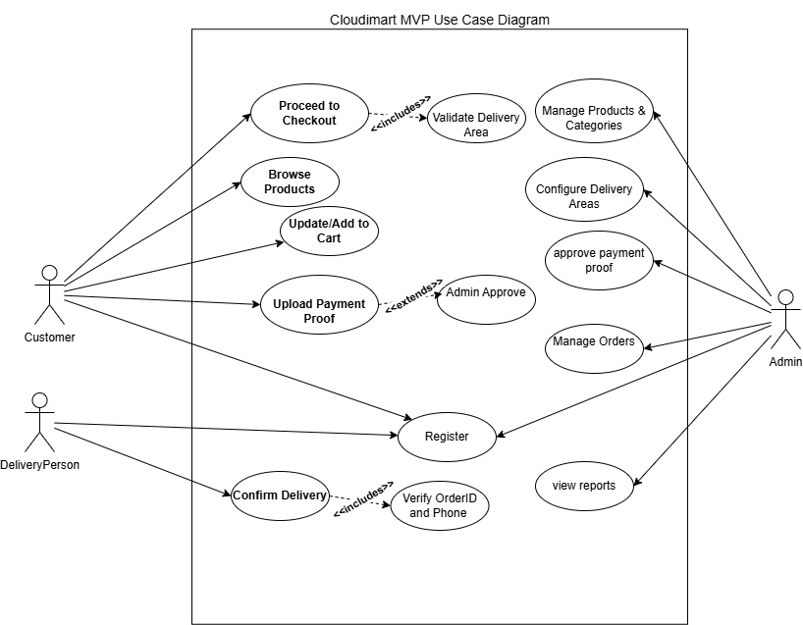
Figure 1: Use case diagram showing interactions of Customer, Admin, and Delivery Person with the system.

3. Location Validation: Approach and Data Collection
No third‑party geocoding API was used for the MVP.
All five delivery areas were defined by manually collecting exact latitude/longitude pairs from Google Maps and seeding them directly into the database. This approach was chosen for its simplicity, zero cost, and complete accuracy for a fixed set of locations.
How Coordinates Were Collected
For each area, I opened Google Maps, located the most recognised landmark (e.g., university main gate, hospital entrance, Luwinga Market), right‑clicked precisely on the spot, and selected “What’s here?” The latitude and longitude appeared in the search box and were copied to six decimal places, a precision of approximately 11 centimetres.
I saved a screenshot of each pin‑drop as evidence and included it in the documentation. The five delivery zones are:
- Mzuzu University (latitude -11.421870, longitude 33.995417, radius 1.5 km)
- Mzuzu Central Hospital (latitude -11.429124, longitude 33.996213, radius 1.2 km)
- Luwinga Market Area (latitude -11.425029, longitude 34.002883, radius 1.8 km)
- Area 1B (latitude -11.403866, longitude 33.995187, radius 1.3 km)
- KAKA Area (latitude -11.415642, longitude 33.992237, radius 1.0 km)

SCREENSHOTS FOR ALL FIVE GOOGLE MAPS PIN‑DROPS WITH COORDINATES
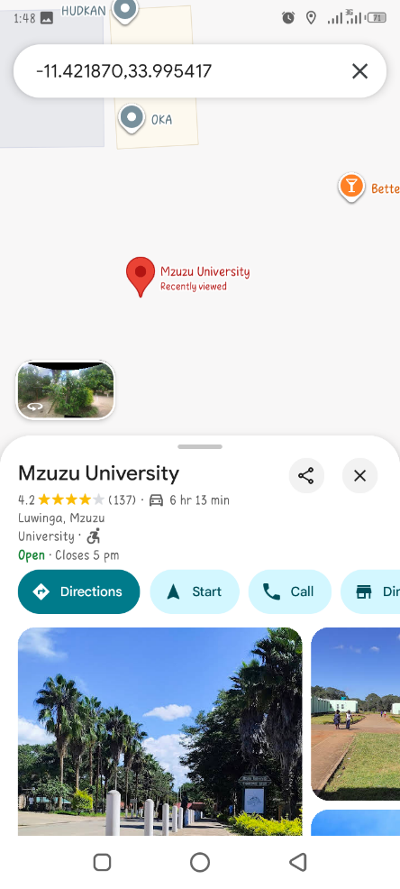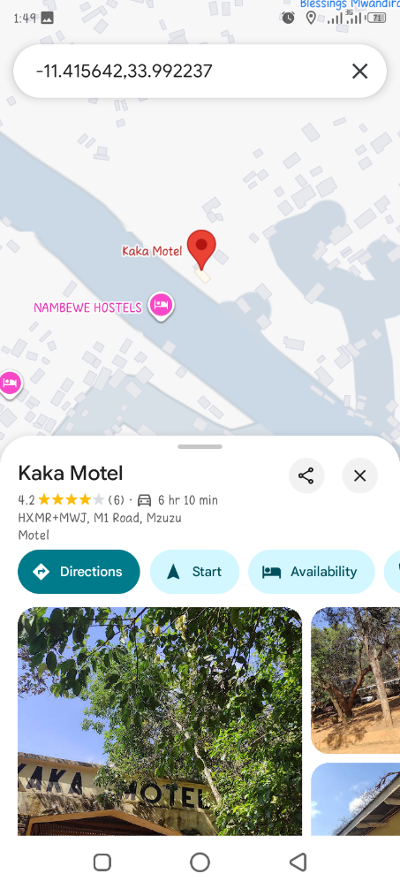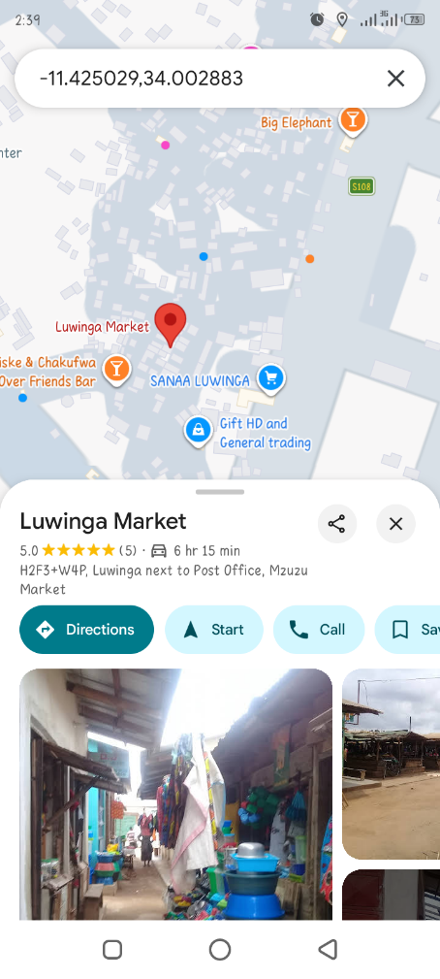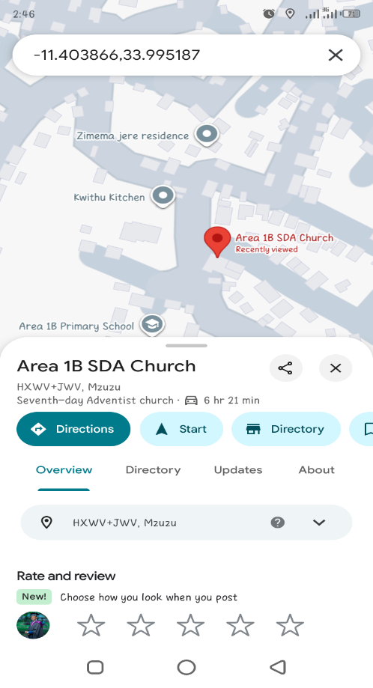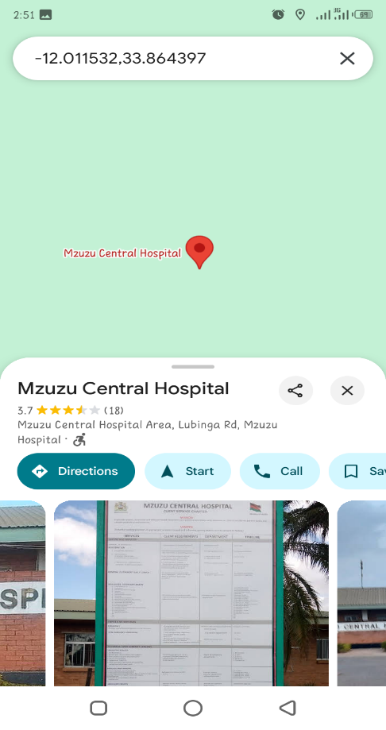
Figure 2: Evidence of coordinate collection, each pin‑drop shows the exact latitude and longitude used for a delivery zone.
Location Validation Logic: Radius, Not Polygons
I deliberately chose radius‑based (circular) geofencing instead of complex polygons for these reasons:
Simplicity: the Haversine formula is easy to implement, test, and explain.
Accuracy: with a radius of 1.0–1.8 km, the entire campus and surrounding residential areas are covered; GPS accuracy (±5–100 m) is more than sufficient.
Maintainability: an admin can adjust a single number (the radius) without redrawing polygons.
Future extension: if required, polygon support can be added later by storing arrays of points and using a point‑in‑polygon algorithm, while the current radius logic remains unchanged for zones where it suffices.
How the Radius-Based Geofencing Works:
Each delivery zone is defined bya center point (latitude/longitude) and a radius (distance in kilometers).
When a user’s location is received the system calculates the straight line distance between the user and the zone center using the haversine formula (which accounts for the earth’s curvature).
If that distance is less than or equal to the radius the user is inside the zone.
Server‑side workflow:
Frontend sends {latitude, longitude} from the browser’s navigator.geolocation.
Backend calculates the Haversine distance to every active delivery location.
If any distance ≤ the location’s radius, checkout is allowed; otherwise a 403 response is returned.

CHECKOUT FLOW WITH LOCATION VALIDATION ACTIVITY AND SEQUENCE DIAGRAMS
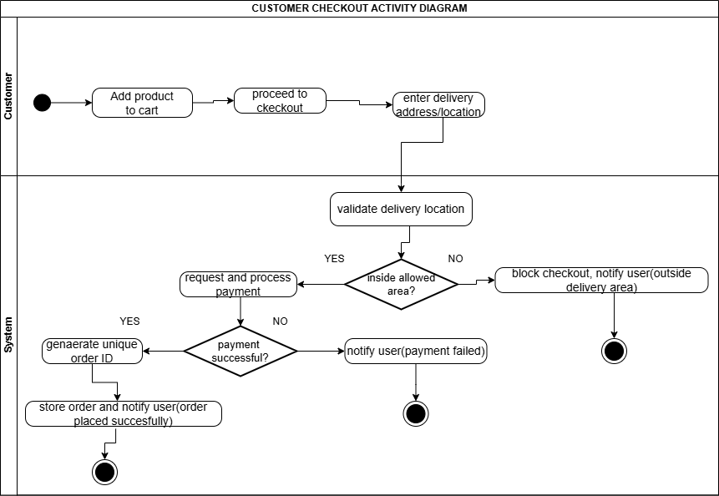
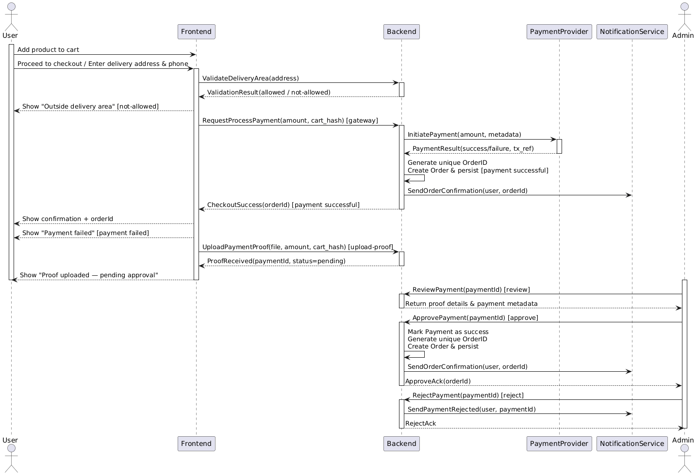
Figure 3 and 4: Activity and Sequence diagrams illustrating the interaction between browser, frontend, backend, and database during location verification and order placement.

4. Technical Architecture
Backend: Laravel 10
- Models & Relationships: Clean, normalised schema: User, Product, Category, Cart, CartItem, Order, OrderItem, Location, Delivery, and Payment.
- Services: LocationService (distance calculation), OrderService (ID generation, order assembly), NotificationService (simulated email/SMS).
- API: RESTful, protected with Laravel Sanctum (token authentication).
- Database: MySQL, with migrations and seeders that include the exact coordinates for all delivery zones.

Frontend: Next.js 14 (App Router)
- TypeScript + Bootstrap CSS: Component‑based, fully responsive.
- State Management: React Context for the shopping cart; React Query for server state and caching.
- Geolocation: Native browser API with a fallback dropdown for users who deny permission.
- Pages: Product listing, product detail, cart, checkout, order confirmation, admin dashboard, delivery verification.
Project Structure (Monorepo Style)
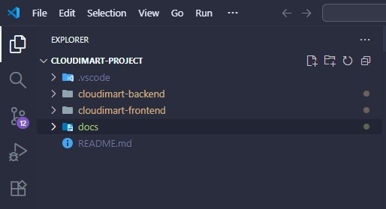
Figure 5: Project folder structure as seen in VS Code.
CLASS DIAGRAM AND ERD
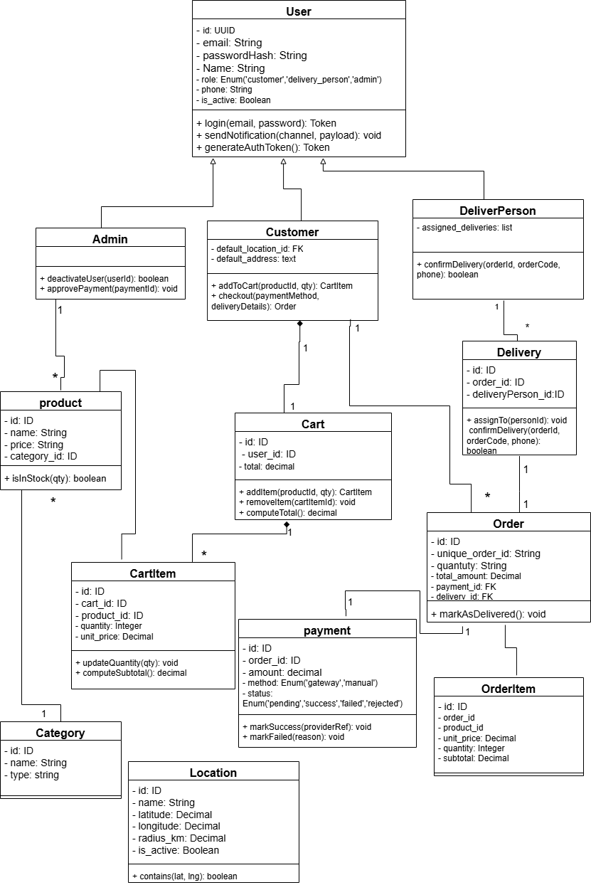
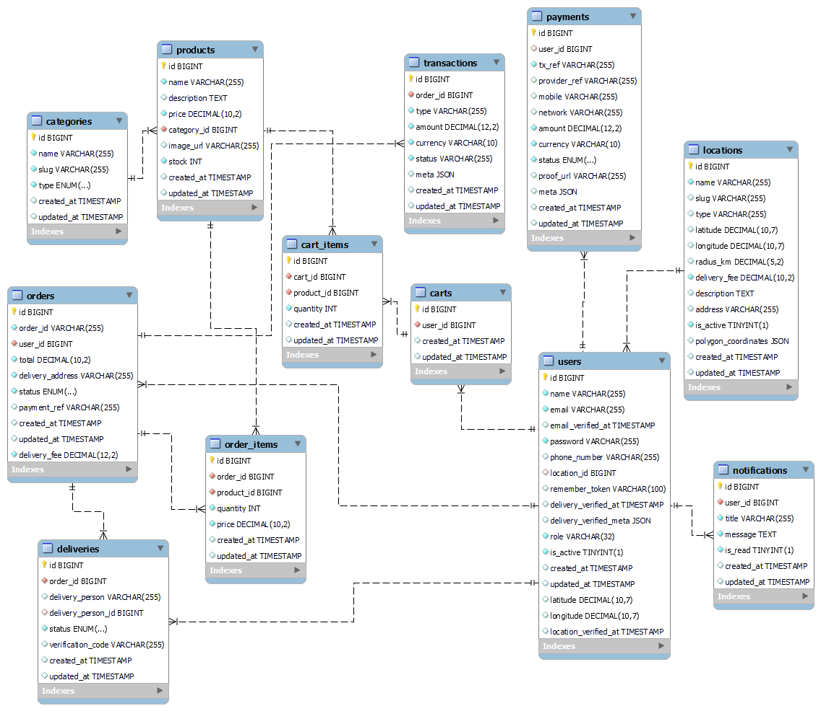
Figure 6 and 7: Class diagram and Entity Relationship Diagram showing all classes, attributes, methods, database tables, fields, and relationships.

5. Software Engineering Principles Applied
- MVC and Separation of Concerns: clearly separated frontend (Nextjs); UI rendering, routing, and API consumption. Backend (Laravel); handles authentication(using laravel sanctum), business logic, and database
- RESTful API Design: Consistent resource naming, appropriate HTTP verbs, meaningful status codes.
- Database Normalization: 3NF, foreign key constraints, indexes on frequently queried columns (e.g., orders.order_id, locations.slug).
- Security: All inputs validated server‑side, Laravel Sanctum for API authentication, CORS configured for the frontend origin, and the use on environment variables for sensitive data such as passwords and API keys.
- DRY (Don’t Repeat Yourself) principle: implemented a shared utilities like a centralized axios client (lib/api/client.ts) for handling headers and tokens; Reusable modals and forms in NextJs react instead of duplicating layout and state logic.
- KISS (Keep It Simple Stupid): for location validation I chose radius based with the haversine formula over polygon based geofencing and the location data was collected manually through google maps and seeded directly into the database avoiding the overhead and cost of a third-party geocoding API.
- Testing: PHPUnit feature tests for critical endpoints (/api/validate-location, /api/orders) and frontend component tests with Jest.
- Version Control: Git with semantic commit messages, and a clean, readable history.

6. Development Approach, Why Backend‑First
The project was executed in three distinct phases:
Phase 1: Backend Foundation
- Database design, migrations, and model relationships.
- Implementation of LocationService and Haversine distance logic.
- Order ID generation trait.
- REST API endpoints for products, cart, orders, and location validation.
Phase 2: Frontend Core
- Next.js setup with Bootstrap CSS and App Router.
- Product listing and cart user interface.
- Geolocation hook and location verification component.
Phase 3: Integration & Polish
- Connecting frontend to the backend APIs.
- Completion of checkout flow and delivery verification.
- Final testing, bug fixes, and documentation.
Why this order?
The core business rules, especially location restriction and atomic order creation, reside in the backend. Defining a stable API contract first allowed the frontend to be developed confidently in parallel.

7. Deliverables & Documentation
- All deliverables are included in the public GitHub repository:
- Full Source Code: Complete Laravel and Next.js applications.
- README.md: Step‑by‑step setup instructions, environment variables, and seeding commands.
- Database ERD: diagram showing all tables, fields, and relationships.
- API Documentation: Markdown file listing every endpoint with example requests and responses.
- Location Research Evidence: Folder containing high‑resolution screenshots of each Google Maps pin‑drop.
- Use Case, Class, Activity and Sequence UML Diagrams, and a Technical Project Summary Documentation.
SEQUENCE/ACTIVITY DIAGRAM: DELIVERY VERIFICATION FLOW
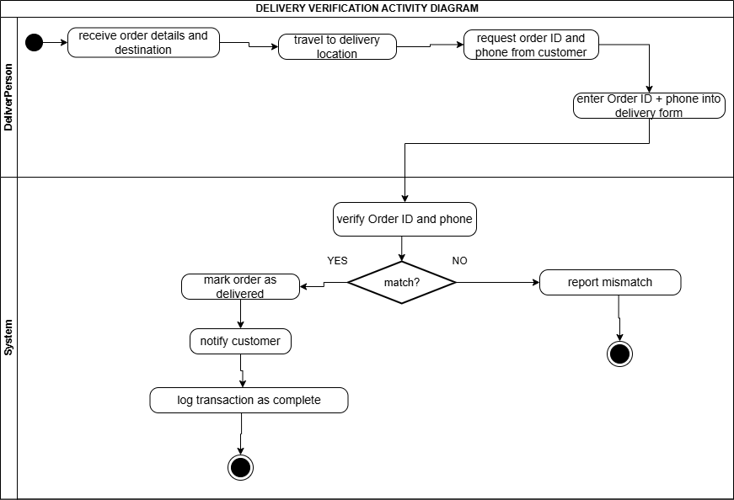

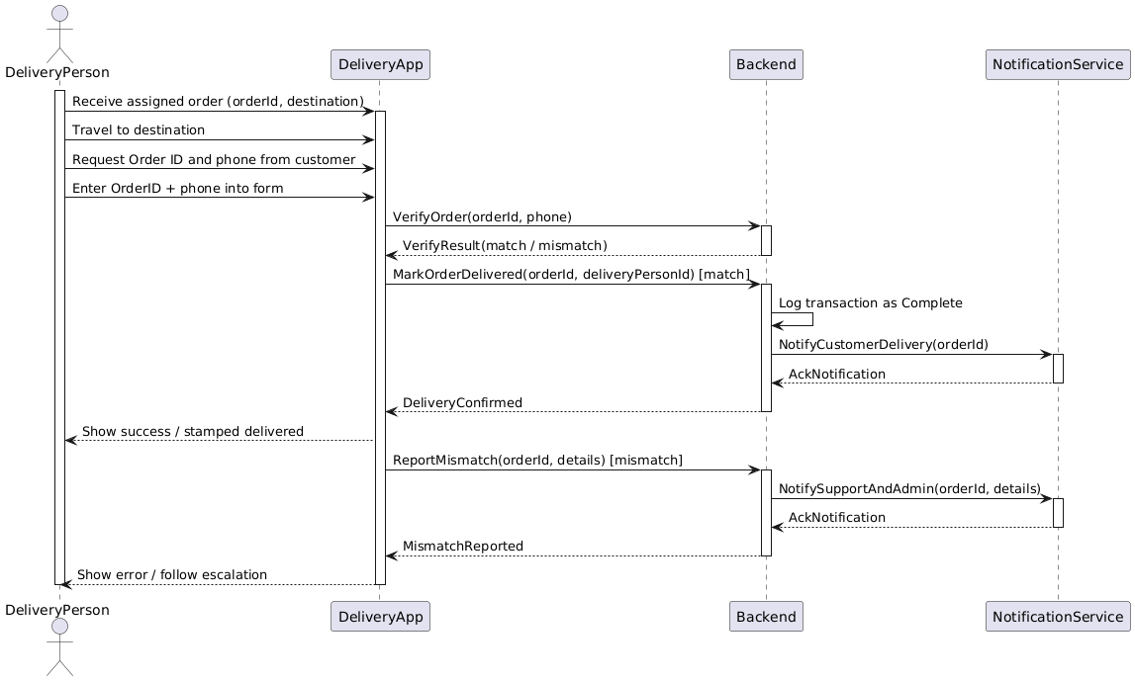
Figure 8 and 9: Activity and Sequence diagram showing the delivery person confirming an order via Order ID and phone number.

8. Quick Setup Guide
To run the prototype locally:
Clone the repository.
Backend: navigate to the backend folder, copy .env.example to .env, and set your database credentials. Run composer install, then php artisan key:generate. Execute php artisan migrate --seed to create tables and seed the delivery zones, products, and admin user. Start the server with php artisan serve --port=8000.
Frontend: in a new terminal, navigate to frontend, copy .env.example to .env.local, and run npm install. Start the development server with npm run dev.
The application will be available at http://localhost:3000
Default admin credentials:
Email: admin@cloudimart.com
Password: secret123
Default deliveryPerson credentials:
Email: deliverPerson@cloudimart.com
Password: secret123

9. Reflection: What I Learned
Manual coordinate collection was the optimal choice for an MVP. It avoided API costs and complexity, taught me how GPS coordinates actually work, and provided perfect accuracy for a fixed set of five locations.
Radius‑based validation is surprisingly effective for campus‑scale delivery. It is simple to implement, debug, and explain.
Screenshots are powerful documentation. They transformed abstract coordinates into credible, verifiable evidence for stakeholders.
Backend‑first development ensured that the location restriction could never be bypassed by a clever frontend client.

10. Conclusion
This prototype meets every functional requirement set by Cloudimart Limited:
- A product catalogue with Stationery and Dairy categories.
- A fully functional shopping cart.
- Checkout restricted to the Mzuzu University community, enforced by GPS and seeded latitude/longitude coordinates.
- Unique, traceable order ID generation.
- Delivery verification workflow using Order ID and phone number.
- Complete transaction logging and admin controls.
The system is ready for a live pilot and can be extended to support real payment gateways, SMS/email providers, and polygon geofencing without any architectural changes.

